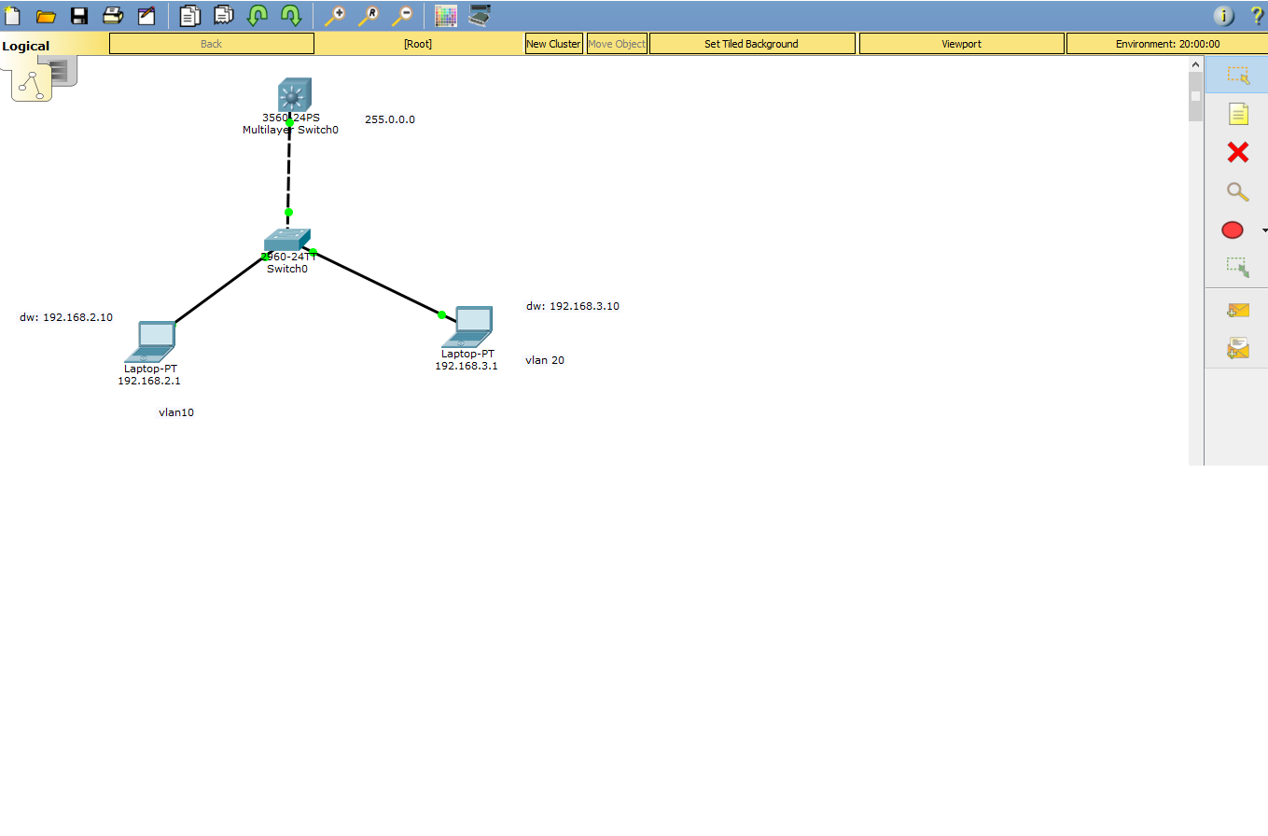

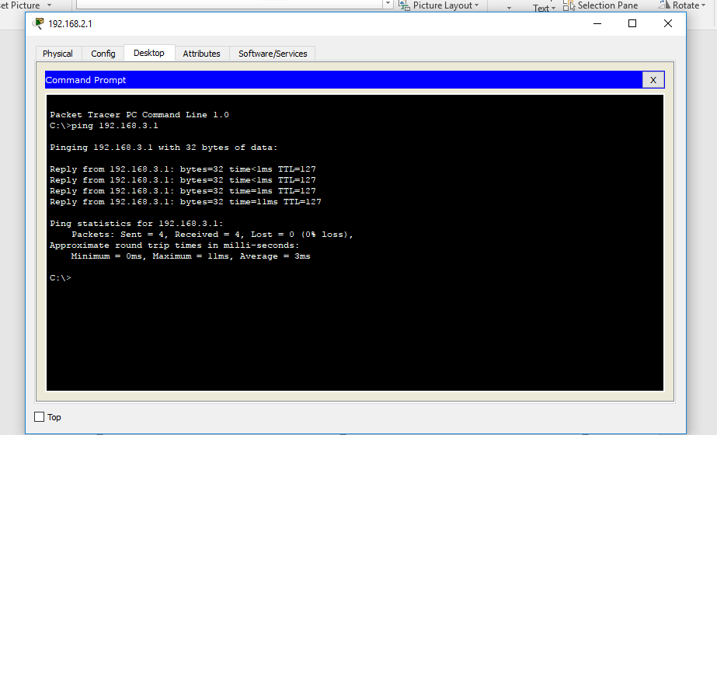

Access port support traffic of particular vlan.

Trunk port support traffic of all vlans.

What we did in lab using given resources

Configuring layer 3 switch

%LINEPROTO-5-UPDOWN: Line protocol on Interface FastEthernet0/1, changed state to down

%LINK-5-CHANGED: Interface FastEthernet0/1, changed state to up

%LINEPROTO-5-UPDOWN: Line protocol on Interface FastEthernet0/1, changed state to up

Switch>

Switch>

Switch>en

Switch#conf t

Enter configuration commands, one per line. End with CNTL/Z.

Switch(config)#vlan 10

Switch(config-vlan)#ex

Switch(config)#vlan 20

Switch(config-vlan)#ex

Switch(config)#int f0/1

Switch(config-if)#switchport trunk en

Switch(config-if)#switchport trunk encapsulation dot1q

Switch(config-if)#swi

Switch(config-if)#switchport mode trunk

Switch(config-if)#ex

Switch(config)#int vlan 10

Switch(config-if)#

%LINK-5-CHANGED: Interface Vlan10, changed state to up

%LINEPROTO-5-UPDOWN: Line protocol on Interface Vlan10, changed state to up

Switch(config-if)#ip add 192.168.2.10 255.0.0.0

Switch(config-if)#no shut

Switch(config-if)#ex

Switch(config)#ip def

Switch(config)#ip defaul

Switch(config)#ip default-gateway 192.168.2.10

Switch(config)#end

Switch#

%SYS-5-CONFIG_I: Configured from console by console

Switch#conf t

Enter configuration commands, one per line. End with CNTL/Z.

Switch(config)#int vlan 20

Switch(config-if)#

%LINK-5-CHANGED: Interface Vlan20, changed state to up

%LINEPROTO-5-UPDOWN: Line protocol on Interface Vlan20, changed state to up

Switch(config-if)#ip add 192.168.3.10 255.0.0.0

% 192.0.0.0 overlaps with Vlan10

Switch(config-if)#no shut

Switch(config-if)#ex

Switch(config)#ip default-gateway 192.168.3.10

Switch(config)#ex

Switch#

%SYS-5-CONFIG_I: Configured from console by console

Switch#conf t

Enter configuration commands, one per line. End with CNTL/Z.

Switch(config)#ip routing

Switch(config)#ex

Switch#

%SYS-5-CONFIG_I: Configured from console by console

Switch#ping

Protocol [ip]: 192.168.3.1

% Unknown protocol - "192.168.3.1", type "ping ?" for help

Switch#ping 192.168.3.1

Type escape sequence to abort.

Sending 5, 100-byte ICMP Echos to 192.168.3.1, timeout is 2 seconds:

.....

Success rate is 0 percent (0/5)

Switch#ping 192.168.3.1

Type escape sequence to abort.

Sending 5, 100-byte ICMP Echos to 192.168.3.1, timeout is 2 seconds:

.....

Success rate is 0 percent (0/5)

Switch#ping 192.168.2.1

Type escape sequence to abort.

Sending 5, 100-byte ICMP Echos to 192.168.2.1, timeout is 2 seconds:

.!!!!

Success rate is 80 percent (4/5), round-trip min/avg/max = 0/1/3 ms

Switch#ping 192.168.3.1

Type escape sequence to abort.

Sending 5, 100-byte ICMP Echos to 192.168.3.1, timeout is 2 seconds:

.....

Success rate is 0 percent (0/5)

Switch#

Switch#configure terminal

Enter configuration commands, one per line. End with CNTL/Z.

Switch(config)#interface FastEthernet0/1

Switch(config-if)#

Switch(config-if)#exit

Switch(config)#interface FastEthernet0/2

Switch(config-if)#

Switch(config-if)#exit

Switch(config)#interface FastEthernet0/3

Switch(config-if)#

Switch(config-if)#exit

Switch(config)#interface FastEthernet0/1

Switch(config-if)#

Switch(config-if)#exit

Switch(config)#interface FastEthernet0/1

Switch(config-if)#

Switch(config-if)#exit

Switch(config)#interface FastEthernet0/2

Switch(config-if)#

Switch(config-if)#exit

Switch(config)#interface FastEthernet0/1

Switch(config-if)#

Switch(config-if)#exit

Switch(config)#interface FastEthernet0/2

Switch(config-if)#

Switch(config-if)#exit

Switch(config)#interface FastEthernet0/1

Switch(config-if)#

Switch(config-if)#exit

Switch(config)#interface FastEthernet0/2

Switch(config-if)#exit

Switch(config)#exit

Switch#

%SYS-5-CONFIG_I: Configured from console by console

Switch#ping 192.168.2.1

Type escape sequence to abort.

Sending 5, 100-byte ICMP Echos to 192.168.2.1, timeout is 2 seconds:

!!!!!

Success rate is 100 percent (5/5), round-trip min/avg/max = 0/0/1 ms

Switch#ping 192.168.3.1

Type escape sequence to abort.

Sending 5, 100-byte ICMP Echos to 192.168.3.1, timeout is 2 seconds:

.....

Success rate is 0 percent (0/5)

Switch#en

Switch#configure terminal

Enter configuration commands, one per line. End with CNTL/Z.

Switch(config)#int vlan 20

Switch(config-if)#

Switch(config-if)#

Switch(config-if)#ip add 192.168.3.10 255.0.0.0

% 192.0.0.0 overlaps with Vlan10

Switch(config-if)#ip add 192.168.3.10 255.255.255.0

% 192.168.3.0 overlaps with Vlan10

Switch(config-if)#exit

Switch(config)#int vlan 10

Switch(config-if)#ip add 192.168.2.10 255.255.255.0

Switch(config-if)#no shut

Switch(config-if)#ex

Switch(config)#ip default-gateway 192.168.2.10

Switch(config)#end

Switch#

%SYS-5-CONFIG_I: Configured from console by console

Switch#

Switch#configure terminal

Enter configuration commands, one per line. End with CNTL/Z.

Switch(config)#int vlan 20

Switch(config-if)#ip add 192.168.3.10 255.255.255.0

Switch(config-if)#no shut

Switch(config-if)#ex

Switch(config)#ip default-gateway 192.168.3.10

Switch(config)#end

Switch#

%SYS-5-CONFIG_I: Configured from console by console

Switch#configure terminal

Enter configuration commands, one per line. End with CNTL/Z.

Switch(config)#ip routing

Switch(config)#ex

Switch#

%SYS-5-CONFIG_I: Configured from console by console

Switch#

Switch#

Switch#ping 192.168.3.1

Type escape sequence to abort.

Sending 5, 100-byte ICMP Echos to 192.168.3.1, timeout is 2 seconds:

.!!!!

Success rate is 80 percent (4/5), round-trip min/avg/max = 0/0/3 ms

Switch#ping 192.168.3.1

Type escape sequence to abort.

Sending 5, 100-byte ICMP Echos to 192.168.3.1, timeout is 2 seconds:

!!!!!

Success rate is 100 percent (5/5), round-trip min/avg/max = 0/1/4 ms

Switch#ping 192.168.2.1

Type escape sequence to abort.

Sending 5, 100-byte ICMP Echos to 192.168.2.1, timeout is 2 seconds:

!!!!!

Success rate is 100 percent (5/5), round-trip min/avg/max = 0/0/2 ms

Switch#

**Configuring Layer 2 switch**

Loading "flash:/c2960-lanbase-mz.122-25.FX.bin"...

########################################################################## [OK]

Restricted Rights Legend

Use, duplication, or disclosure by the Government is

subject to restrictions as set forth in subparagraph

(c) of the Commercial Computer Software - Restricted

Rights clause at FAR sec. 52.227-19 and subparagraph

(c) (1) (ii) of the Rights in Technical Data and Computer

Software clause at DFARS sec. 252.227-7013.

cisco Systems, Inc.

170 West Tasman Drive

San Jose, California 95134-1706

Cisco IOS Software, C2960 Software (C2960-LANBASE-M), Version 12.2(25)FX, RELEASE SOFTWARE (fc1)

Copyright (c) 1986-2005 by Cisco Systems, Inc.

Compiled Wed 12-Oct-05 22:05 by pt_team

Image text-base: 0x80008098, data-base: 0x814129C4

Cisco WS-C2960-24TT (RC32300) processor (revision C0) with 21039K bytes of memory.

24 FastEthernet/IEEE 802.3 interface(s)

2 Gigabit Ethernet/IEEE 802.3 interface(s)

63488K bytes of flash-simulated non-volatile configuration memory.

Base ethernet MAC Address : 0050.0FB5.B687

Motherboard assembly number : 73-9832-06

Power supply part number : 341-0097-02

Motherboard serial number : FOC103248MJ

Power supply serial number : DCA102133JA

Model revision number : B0

Motherboard revision number : C0

Model number : WS-C2960-24TT

System serial number : FOC1033Z1EY

Top Assembly Part Number : 800-26671-02

Top Assembly Revision Number : B0

Version ID : V02

CLEI Code Number : COM3K00BRA

Hardware Board Revision Number : 0x01

Switch Ports Model SW Version SW Image

------ ----- ----- ---------- ----------

* 1 26 WS-C2960-24TT 12.2 C2960-LANBASE-M

Cisco IOS Software, C2960 Software (C2960-LANBASE-M), Version 12.2(25)FX, RELEASE SOFTWARE (fc1)

Copyright (c) 1986-2005 by Cisco Systems, Inc.

Compiled Wed 12-Oct-05 22:05 by pt_team

Press RETURN to get started!

%LINK-5-CHANGED: Interface FastEthernet0/1, changed state to up

%LINEPROTO-5-UPDOWN: Line protocol on Interface FastEthernet0/1, changed state to up

%LINK-5-CHANGED: Interface FastEthernet0/2, changed state to up

%LINEPROTO-5-UPDOWN: Line protocol on Interface FastEthernet0/2, changed state to up

%LINK-5-CHANGED: Interface FastEthernet0/3, changed state to up

%LINEPROTO-5-UPDOWN: Line protocol on Interface FastEthernet0/3, changed state to up

Switch>en

Switch#config t

Enter configuration commands, one per line. End with CNTL/Z.

Switch(config)#vlan 10

Switch(config-vlan)#ex

Switch(config)#vlan 20

Switch(config-vlan)#ex

Switch(config)#int f0/1

Switch(config-if)#swi

Switch(config-if)#switchport acc

Switch(config-if)#switchport access vlan 10

Switch(config-if)#int

Switch(config-if)#int f0/2

Switch(config-if)#swi

Switch(config-if)#switchport acc

Switch(config-if)#switchport access vlan 20

Switch(config-if)#exit

Switch(config)#int f0/1

Switch(config-if)#switchport access vlan 10

Switch(config-if)#exit

Switch(config)#int f0/2

Switch(config-if)#switchport access vlan 20

Switch(config-if)#exit

Switch(config)#swit

Switch(config)#swit

Switch(config)#int f0/3

Switch(config-if)#switchport mode trunk

Switch(config-if)#

%LINEPROTO-5-UPDOWN: Line protocol on Interface FastEthernet0/3, changed state to down

%LINEPROTO-5-UPDOWN: Line protocol on Interface FastEthernet0/3, changed state to up

Switch(config-if)#ex

Switch(config)#ex

Switch#

%SYS-5-CONFIG_I: Configured from console by console

Switch#sh vlan

VLAN Name Status Ports

---- -------------------------------- --------- -------------------------------

1 default active Fa0/4, Fa0/5, Fa0/6, Fa0/7

Fa0/8, Fa0/9, Fa0/10, Fa0/11

Fa0/12, Fa0/13, Fa0/14, Fa0/15

Fa0/16, Fa0/17, Fa0/18, Fa0/19

Fa0/20, Fa0/21, Fa0/22, Fa0/23

Fa0/24, Gig0/1, Gig0/2

10 VLAN0010 active Fa0/1

20 VLAN0020 active Fa0/2

1002 fddi-default active

1003 token-ring-default active

1004 fddinet-default active

1005 trnet-default active

VLAN Type SAID MTU Parent RingNo BridgeNo Stp BrdgMode Trans1 Trans2

---- ----- ---------- ----- ------ ------ -------- ---- -------- ------ ------

1 enet 100001 1500 - - - - - 0 0

10 enet 100010 1500 - - - - - 0 0

20 enet 100020 1500 - - - - - 0 0

1002 fddi 101002 1500 - - - - - 0 0

--More--

%LINK-5-CHANGED: Interface FastEthernet0/1, changed state to down

%LINEPROTO-5-UPDOWN: Line protocol on Interface FastEthernet0/1, changed state to down

%LINK-5-CHANGED: Interface FastEthernet0/1, changed state to up

%LINEPROTO-5-UPDOWN: Line protocol on Interface FastEthernet0/1, changed state to up

%LINK-5-CHANGED: Interface FastEthernet0/2, changed state to down

%LINEPROTO-5-UPDOWN: Line protocol on Interface FastEthernet0/2, changed state to down

%LINK-5-CHANGED: Interface FastEthernet0/2, changed state to up

%LINEPROTO-5-UPDOWN: Line protocol on Interface FastEthernet0/2, changed state to up

%LINK-5-CHANGED: Interface FastEthernet0/3, changed state to down

%LINEPROTO-5-UPDOWN: Line protocol on Interface FastEthernet0/3, changed state to down

%LINK-5-CHANGED: Interface FastEthernet0/3, changed state to up

%LINEPROTO-5-UPDOWN: Line protocol on Interface FastEthernet0/3, changed state to up

1003 tr 101003 1500 - - - - - 0 0

1004 fdnet 101004 1500 - - - ieee - 0 0

1005 trnet 101005 1500 - - - ibm - 0 0

Remote SPAN VLANs

------------------------------------------------------------------------------

Primary Secondary Type Ports

------- --------- ----------------- ------------------------------------------

Switch#

Switch#

Switch#

Switch#